UNEP

**Meet the Chairs**

President - Timothy Shankar

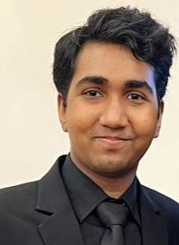Vice President - Rayan Hettiarachchi

Vice President - Kaashyapa Kalusinghe